Following Bedlington West End First School on Twitter: A Guide For Parents and Carers
In order to follow Bedlington West End First School’s Twitter page, you need to have a Twitter account.
If you already have a Twitter account:
- Log into your Twitter account using your username and password.

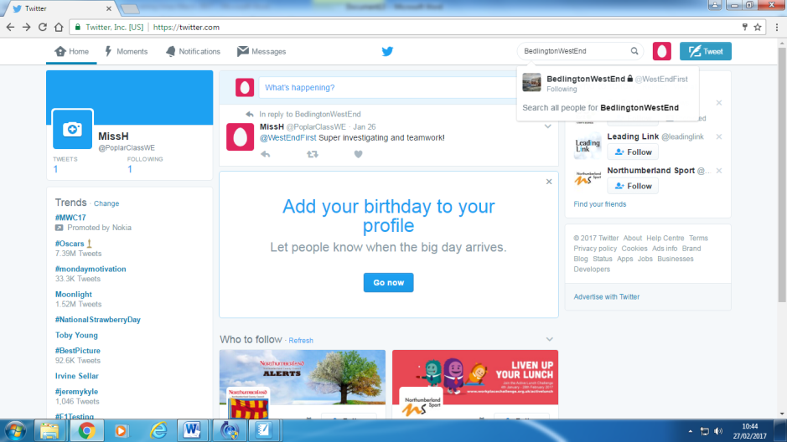
- In the search bar type: BedlingtonWestEnd. You may need to set the search setting to people if searching for the first time.

- Click follow on Bedlington West End First School’s icon.

- Your request to follow Bedlington West End First School’s Twitter page will be sent to the administrator. Once your request has been approved, you will be able to see and comment on, the Twitter page belonging to the school.

- In order for the administrator to approve your request, you will need to fill in a form with your Twitter account details and information about your child/children so that the school can monitor who has access to the Twitter page. This is to ensure appropriate levels of security. You will also need to agree to the terms outlined in the school’s Social Media Acceptable Use Policy.

If you do not have a Twitter account, you will need to set up an account
- In your internet browser, search for Twitter.

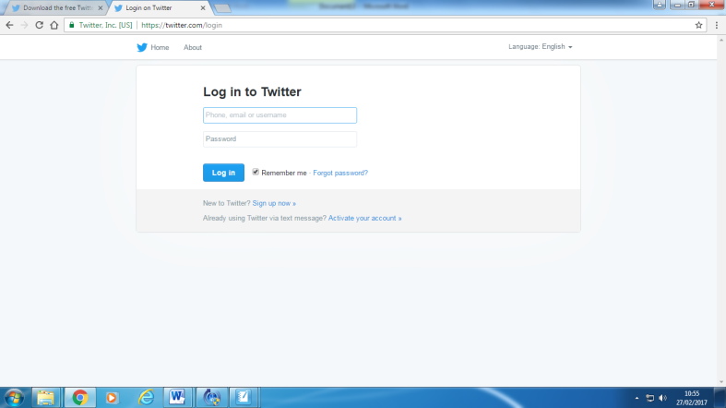
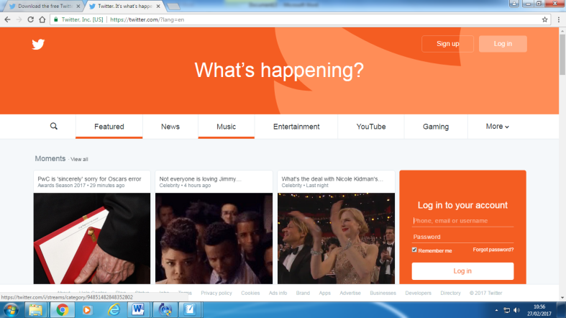
- Click on the link which will take you to Twitter’s home page. It should look like this one of these screens:

- Click the sign up button.

- Enter your full name, email address and choose a password then click sign up.
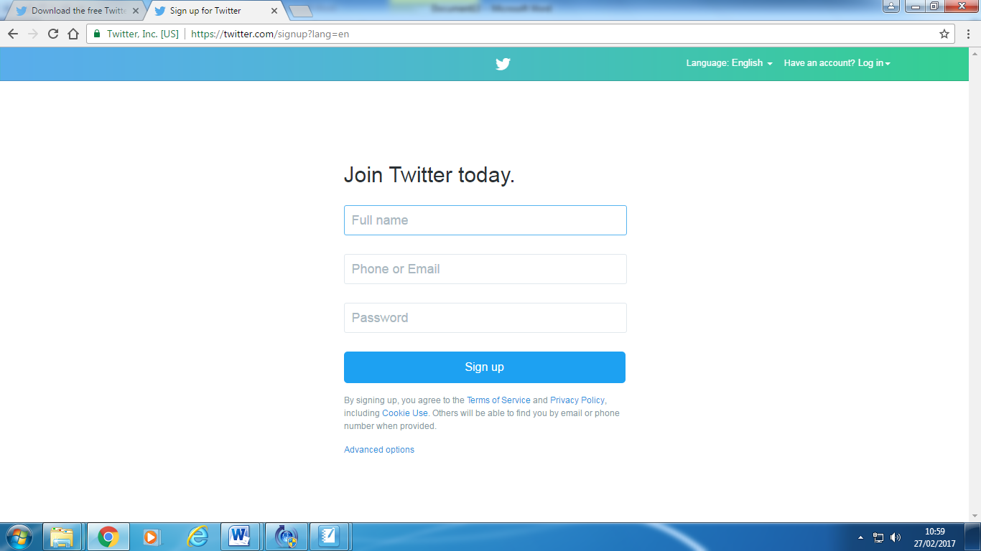

- Once you have clicked sign up, there is an option to enter a telephone number. You can skip this option by clicking skip.

- You will then be requested to choose a username that will appear on screen. A suggestion would be your first initial and surname or a username that enables you to be recognised easily! This username should not contain word spaces! If your username is already taken, you will need to choose an alternative username. This username will appear on your home page as @(username you have chosen)

- Follow the on-screen instructions to finish setting up your account.

To follow Bedlington West End First School’s Twitter Page
- Log into your Twitter account using your username and password.

- In the search bar type: BedlingtonWestEnd. You may need to set the search setting to people if searching for the first time.

- Click follow on Bedlington West End First School’s icon.

- Your request to follow Bedlington West End First School’s Twitter page will be sent to the administrator. Once your request has been approved, you will be able to see and comment on, the Twitter page belonging to the school.

- In order for the administrator to approve your request, you will need to fill in a form with your Twitter account details and information about your child/children so that the school can monitor who has access to the Twitter page. This is to ensure appropriate levels of security. You will also need to agree to the terms outlined in the school’s Social Media Acceptable Use Policy.

Request to Follow Bedlington West End First School’s Twitter Page
Please fill out the form below and return to school once you have created your Twitter account and have sent a follow request to the Administrator. If you request more than one person in your family to be able to access Bedlington West End First School’s Twitter page, please complete the additional boxes. Please note that school will not ask you for your Twitter password details.
I agree:
- To images of my child being uploaded by the school onto Bedlington West End First School’s Twitter page.
- All photographs on Bedlington West End First School’s Twitter page will be used for private use only.
- No images will be copied from Bedlington West End First School’s Twitter page and stored on a personal computer or portable device.
- No images from Bedlington West End First School’s Twitter page will be uploaded onto any other social networking site or website.
- I will not name any pupils in any comments I make on Bedlington West End First School’s Twitter page.
- I will not use the Bedlington West End First School Twitter page to complain about the pupils, staff, governors or parents of Bedlington West End First School, or the actions of the school.
- I will not use the Bedlington West End First School Twitter account to make unkind, malicious or hurtful comments about the pupils, staff, parents or governors of Bedlington West End First School, or the actions of the school. Any comments I make on Bedlington West End First School’s Twitter page will be respectful and in-keeping with the ethos of the school.
- I will not use the Bedlington West End First School Twitter account to communicate with staff about my child’s education, welfare or the actions of the school or expect staff to respond to my comments.
- I will ensure that any Additional Users I have identified also agree to the above.
- I understand that my account may be blocked or reported if any of the above conditions are breached.
Signed: _______________________________________
Parent / Carer’s Full Name: ___________________________________
Twitter Username: (eg@abcde12345) ___________________________
Name of child / children in school:
____________________________ Year _______
____________________________ Year _______
____________________________ Year _______
Your relationship to the child / children: __________________________

Additional Follower Request: ___________________________________________
Twitter Username: (eg@abcde12345) ____________________________________
Relationship to the child / children: _____________________________________

Additional Follower Request: ___________________________________________
Twitter Username: (eg@abcde12345) ____________________________________
Relationship to the chid / children: _____________________________________

Additional Follower Request: ___________________________________________
Twitter Username: (eg@abcde12345) ____________________________________
Relationship to the chid / children: _____________________________________

